Reading and Sending Messages

Course Messages is a communication tool inside Blackboard that allows instructors and students to interact through an internal message system unique to each course.

You have two options for accessing the Course Messages tool.
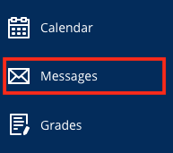
- From the base navigation menu, click Messages.
  - Here you will see a list of your courses.
  - The number of messages in each will appear at the bottom of the course information box.
  - Click anywhere on the course information box to open up that course’s messages tool and view your inbox and sent folders.
    - Click Inbox to see messages sent to you.
    - Click Sent to view messages you sent to others in the course.
  - To create and send a message to someone in a specific course, select the on the right side of the course information box.

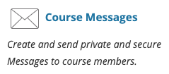
- From inside your course, click Tools in the menu and then select Course Messages.
  - Note: If you do not see Course Messages, it is because your instructor prefers another contact method. Check your syllabus to find out their preferred method.
  - Within the Course Messages tool, click on Inbox to view messages sent to you or click on Sent to see messages you sent to others in the course.
  - To create and send a message to someone in the current course, click the button.

No matter which option you choose to access Course Messages, once you proceed to reading or creating messages, the steps are the same.

Reading Messages
Once you enter the Course Messages tool, you will see your inbox and sent folders.

Click Inbox to read your messages. If you have unread messages, a tally will display below the Unread heading across from your Inbox link. There is also a Total inbox messages tally.

You can view and verify your sent messages by clicking on Sent. Tallies display for Unread and Total sent messages as well.

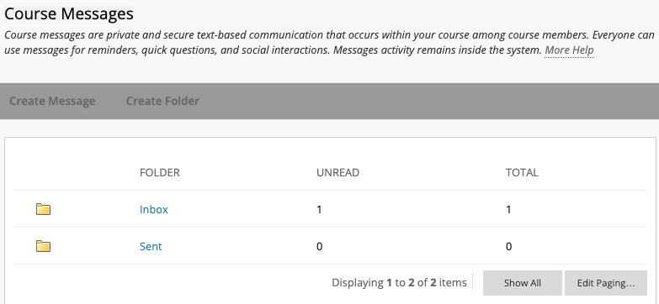

From your inbox, click the subject line of the message you want to read.

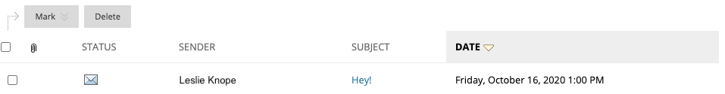

Once a message has been opened, you will have the option to Reply (to Sender or All), Forward, Delete, or Print the message.

To return to your inbox after reading the message, click the OK button at the bottom.

Sending Messages
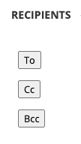
After you have clicked the (from base navigation) or the button (from the Course Messages tool within a course), you will be able to compose a message to anyone enrolled in the course, including your instructor.

Click the To button to choose your recipient for the message. The only recipients available are those who are in the course. It is not possible to send a message to anyone outside of the course.

To select your recipient, click on their name in the left column to highlight it. Next, click the > arrow to move them into the Recipients list on the right side.

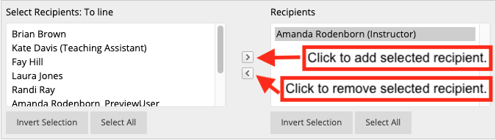

Enter your subject and message in the boxes provided.

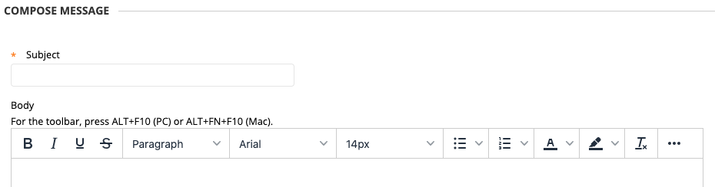

You can also attach a file by using the button.

When ready, click Submit to send your message.

